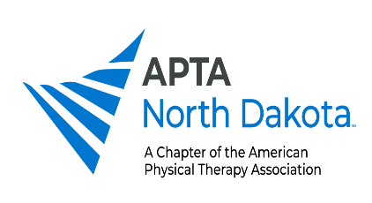
Interventions to Consider
Blood-flow restriction training is achieved through the application of external pressure over the extremities. The applied pressure is sufficient to maintain arterial inflow while occluding venous outflow distal to the occlusion site. The resulting vascular occlusion causes similar anaerobic environment created during heavy lifting. The goal is to enable patients to make greater strength gains while lifting lighter loads, thereby reducing the overall stress placed on the limb.
https://www.apta.org/patient-care/interventions/blood-flow-restriction/what-to-know-about-blood-flow-restriction-training
Diagnostic Musculoskeletal Ultrasound (MSKU) is an evidence-based, cost efficient, imaging modality. MSKU has diagnostic accuracy comparable to magnetic resonance imaging (MRI) for common soft tissue pathology, including enthesopathy, tendinopathy, ligament pathology, joint pathology, and compressive neuropathies of the upper extremity. Utilized also with dry needling for greater treatment effect.
https://spinalmanipulation.org/dates-and-locations/msku-1/
Dry needling is insertion of thin monofilament needles, as used in acupuncture, to affect neural, muscular, and connective tissues locally and via regional interdependence. Electrical stimulation as well as manipulation of needles, such as winding/pecking/fanning/coning, can be used to affect multiple tissue and create a physiological response, thus down regulating the nervous system and resulting in decreased pain response.
https://spinalmanipulation.org/wp-content/uploads/2017/07/peripheral-and-spinal-mechanisms-of-pain-and-dry-needling-mediated-analgesia-a-clinical-resource-guide-for-health-care-professionals-butts-et-al-2016.pdf
Extracorporeal shockwave therapy (ESWT) uses transcutaneous application of high-energy acoustic shockwaves to break up soft tissue calcifications, enhance collagen synthesis, release growth factors, and stimulate your body’s healing process. ESWT enhances blood circulation and accelerates the healing of stubborn musculoskeletal conditions in bones, tendons, ligaments, and muscle.
https://www.ncbi.nlm.nih.gov/pmc/articles/PMC9321712/

